How to Request a Cell Phone Allowance
From the Peoplesoft Website, select Additional Pay Request Form on the bottom right hand side of the page.
https://www.utep.edu/vpba/peoplesoft/forms/index.html

Additional Pay Request Form
The Additional Pay Request form is used when requesting payment to full time faculty or staff for additional duties performed outside their full time job function.
You should use this form for the following payments:
- Communication Device Allowances
- Temporary/Additional Duties
- Instructional Teaching/Course Development
- Recognitions
- Mini-mesters
Access the Additional Pay Request Form
Enter the Employee ID of the employee that is to receive the Cell Phone Allowance:
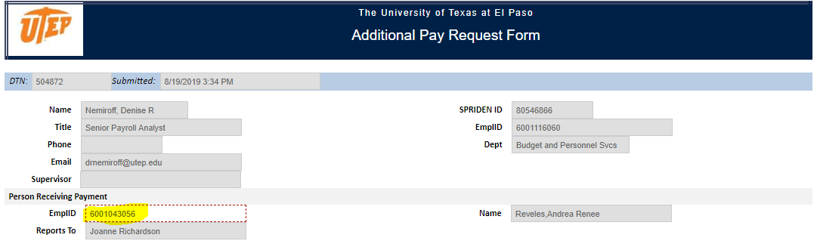
Choose Communication Device Allowance from the drop down on the Type of Payment:
Select the position number for the employee’s current position:
Enter a Justification for the supplemental payment request:
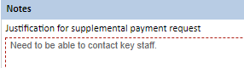
Select the position number for the CDA to be paid on:
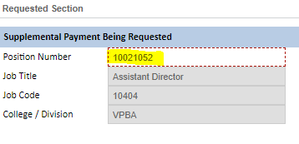
Choose a Monthly Amount, which must be in increments of $25, and the beginning and end dates:
Enter the Funding Source, Funding Begin and End Dates, and the distribution percentage, which should equal 100:
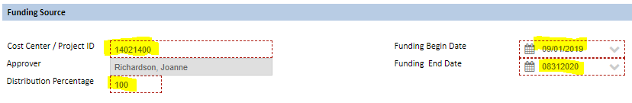
Click the Green OK.
The Additional Pay IAP will route to the employee to approve, then to all other approvers, until it is entered into Peoplesoft.

